-3\*w

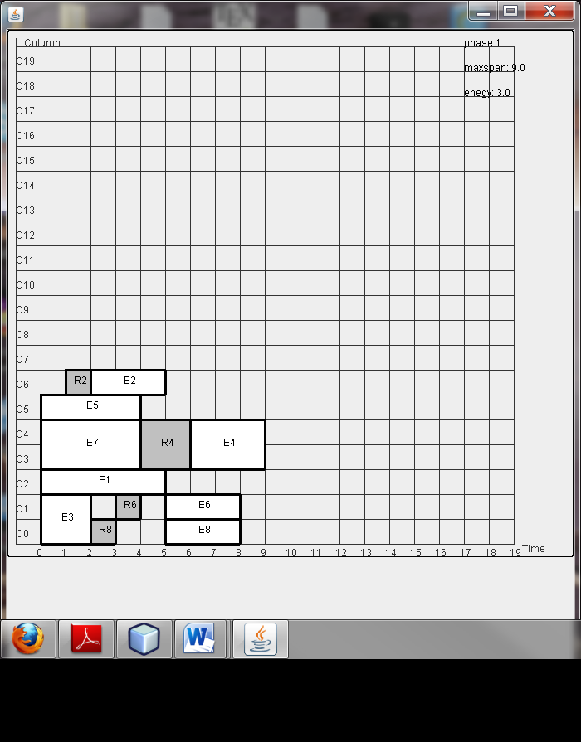

Exmaple 2- with leakage aware placement lk=0, est>0 (est>>lk) or

Without leakage placement

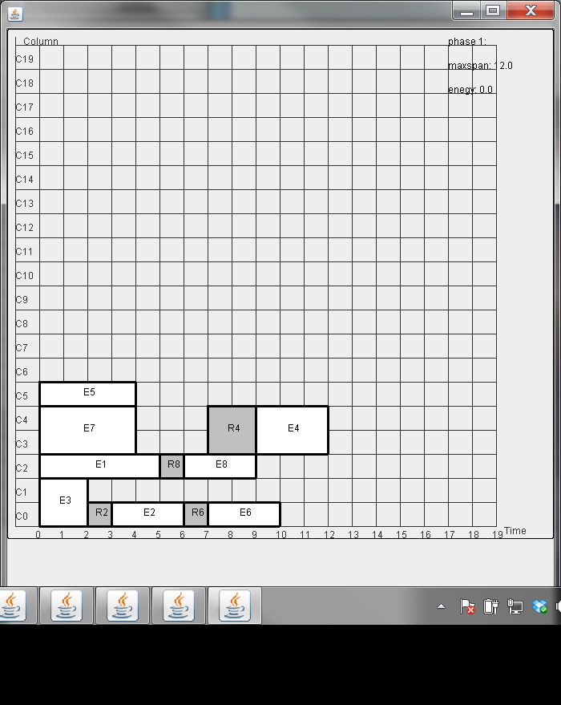

Exmaple 2- with leakage aware placement lk=2, est=20 (est>>lk) or